### Fully Dressed: Use Case Model 2

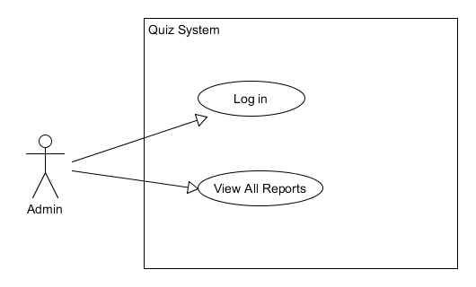

**Primary Actor:** Admin.

**Goal in context**: Admin logs in views overall class report.

**Level:** Admin Level.

**Stake Holders and Interests:** Admin wants to see all student results and the attempts on quiz.

**Preconditions:** The system is up and running with data from the students doing the quiz.

**Success Guarantees:** Admin access the quiz system’s overall class report.

**Trigger:** Admin Logs in to Quiz system

**Main success scenario:**

1. Admin logs in.
2. A report of all student’s attempts is displayed.
3. Admin hits any key.
4. System then logs the Admin out.

**Extensions:**

1a. Admin’s login details entered is wrong, and is asked for them again.